Create and query an Azure SQL data warehouse in the Azure portal

**Step 1:** Sign into your Azure Portal using your credentials and click on **Create a resource** in the upper left-hand corner of the Azure portal and select **SQL Data Warehouse** from the **Databases** category. Fill the necessary details as below to create your SQL Data Warehouse

**Database name**: Any name as an identifier

**Subscription:** Select your subscription

**Resource group**: Create a new resource group with a name

**Select source**: Select sample

**Select sample:** Select AdventureWorksDW

**Server:** Create a new server with unique name and login creadentails. Select a location nearest to you.

**Perfomance level:** Select DW400 (default)

Click on **Create** to provision the database and wait for few mintues for the provision to be succeded.

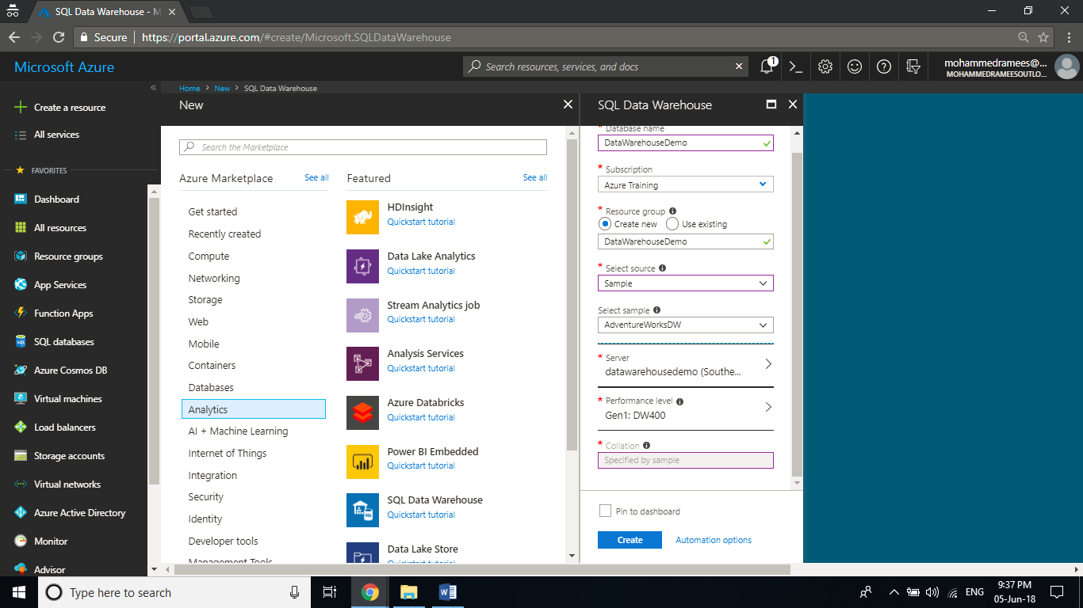

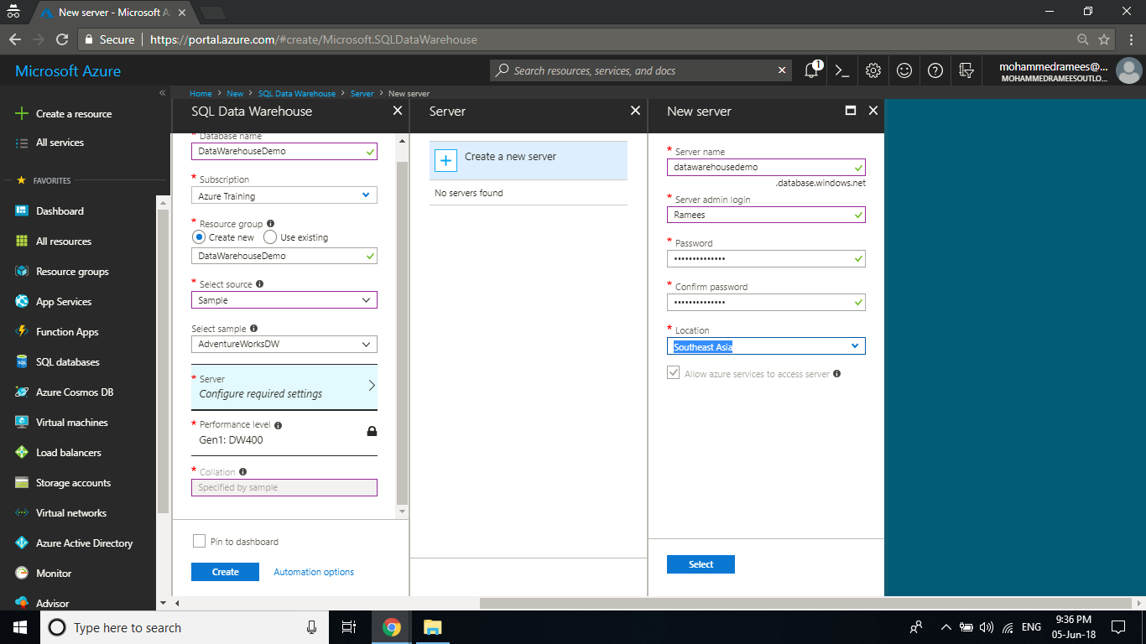

**Step 2:** Once the provision is completed open the resource and you can see the settings blade for the newly created Azure Data Warehouse. Click on the **Server name** to open the settings for the server.

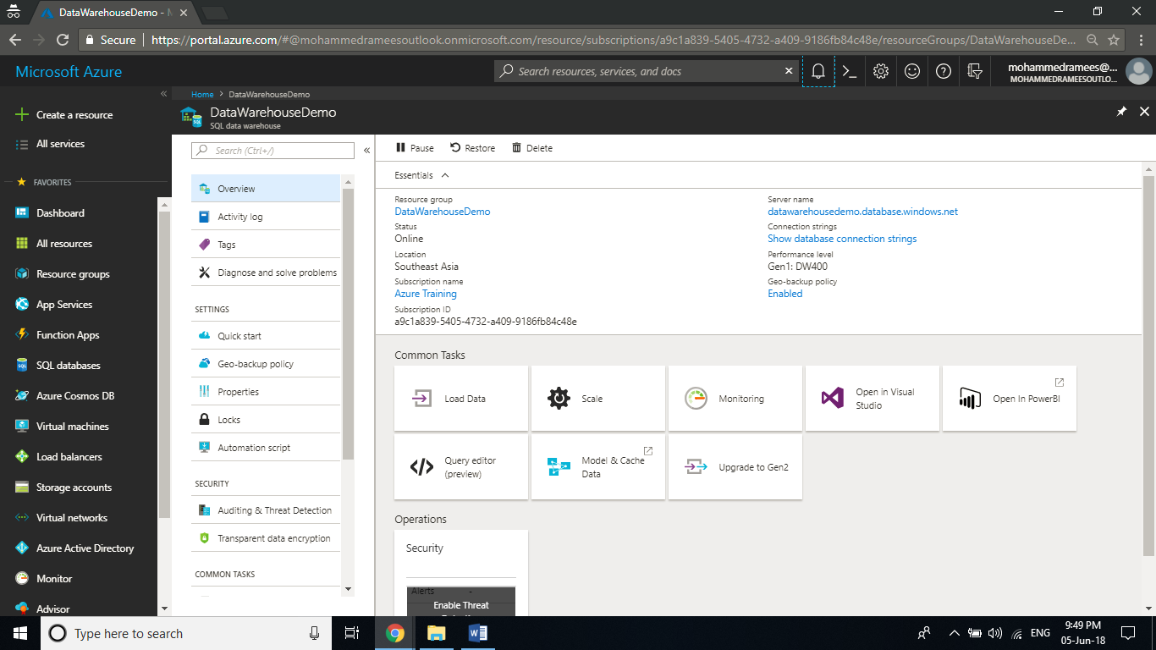

**Step 3:** Now you have got the settings for the server. The SQL Data Warehouse service creates a firewall at the server-level that prevents external applications and tools from connecting to the server or any databases on the server. To enable connectivity, you can add firewall rules that enable connectivity for specific IP addresses. Click on **Show Firewall** **settings** to create a server-level firewall rule for your client's IP address.

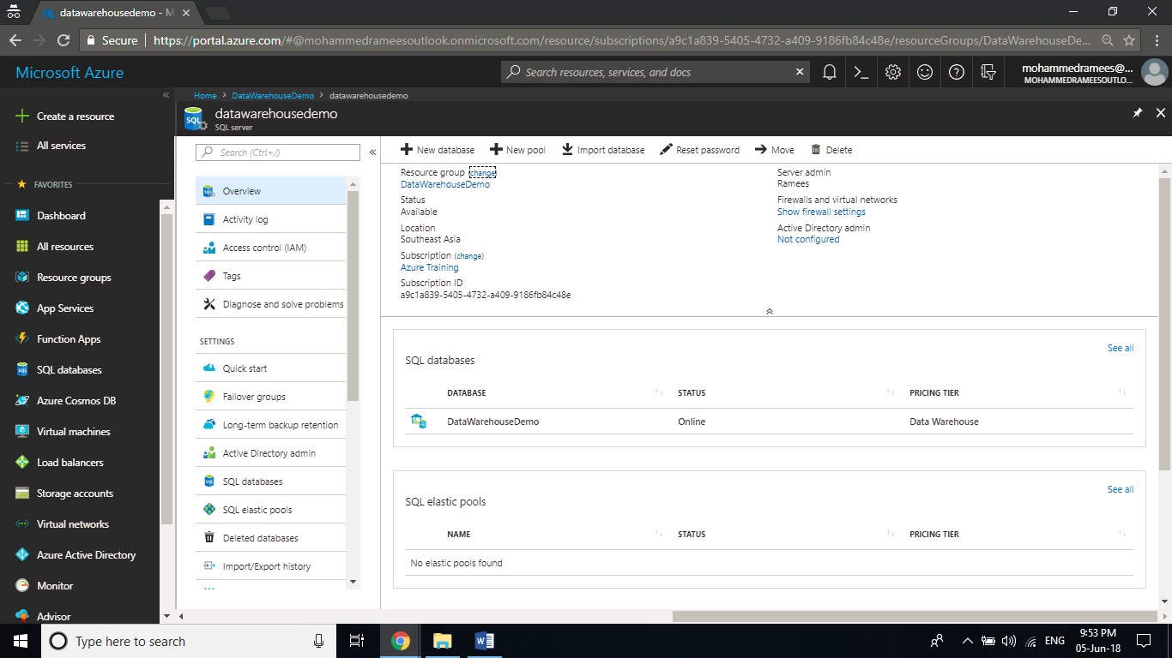

**Step 4:** It will open the List of Client IPs allowed to access the server. Click on **Add client IP** to add your current IP address, and click on **Save** to save the changes. A firewall rule can open port 1433 for a single IP address or a range of IP addresses.

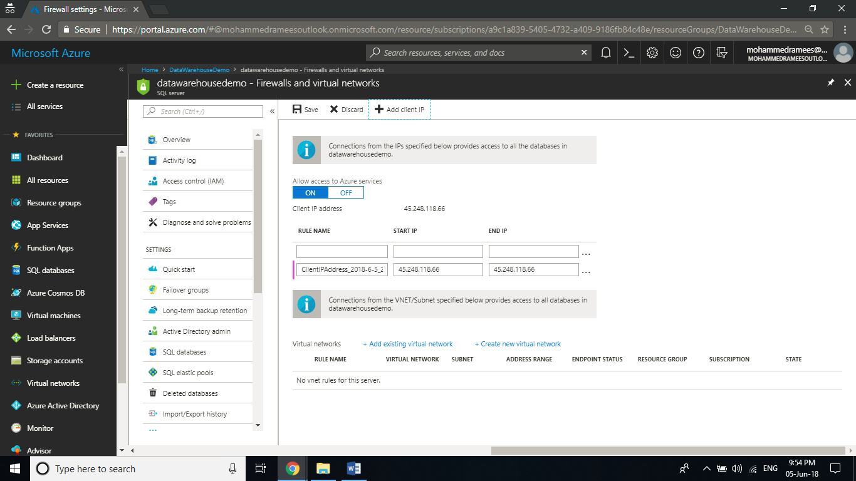

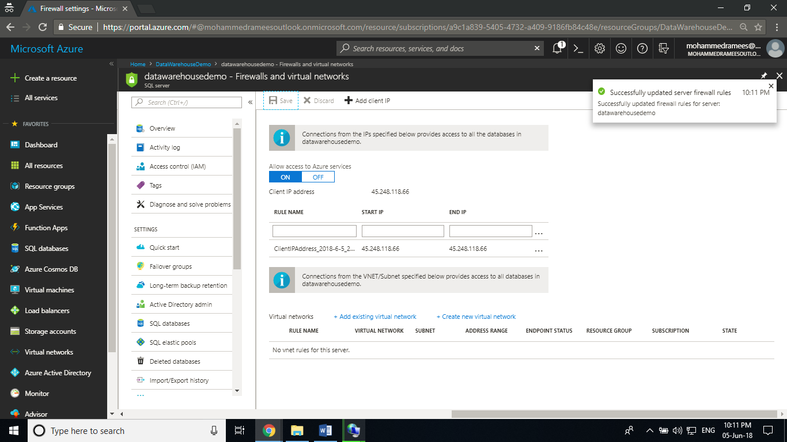

**Step 5:** Now let’s connect to the server as server admin. For that we have to use SQL Server Management Studio (SSMS) to establish a connection to your Azure SQL server. Open SQL Server Management Studio and in the connect to Sever tab, copy and paste your server name, change Authentication to SQL Server Authentication and provide your login name and password you configured while creating the server. Click on connect

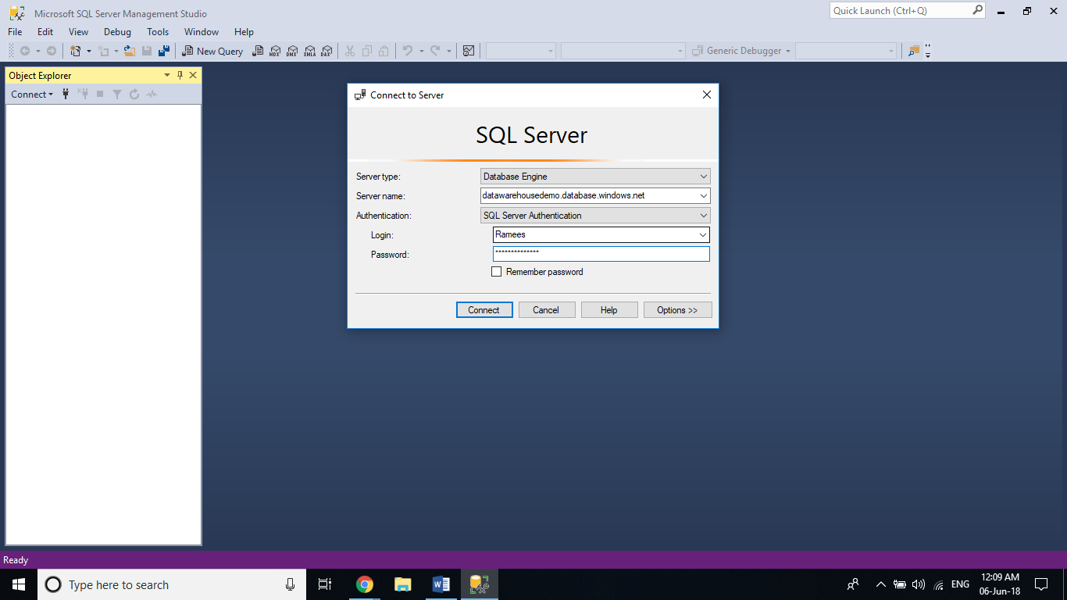

**Step 6:** On successful connection it will open the object explorer. In Object Explorer, **expand Databases**. Then expand **mySampleDatabase** to view the objects in your new database.

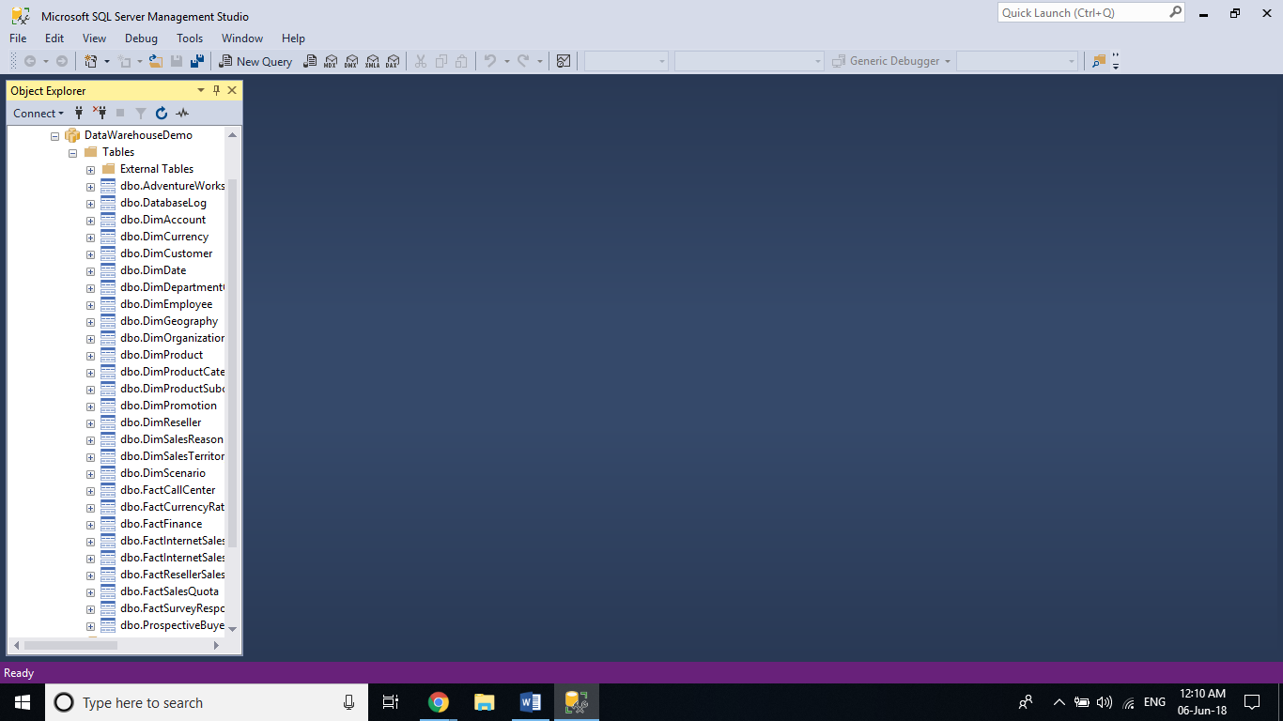

**Step 7:** SQL Data Warehouse uses T-SQL as the query language. To open a query window and run some T-SQL queries, Right-click mySampleDataWarehouse and select New Query will open a new query window. Enter the following queries.

